***Season-storage_integration***

create or replace storage integration integration_PBI

type = external_stage

storage_provider = 'S3'

enabled = true

storage_aws_role_arn = 'arn:aws:iam::222634379646:role/powerbi_role'

storage_allowed_locations = ('s3://powerbi-season.proj/')

comment = 'optional comment'

//description integration obj

desc integration integration_PBI;

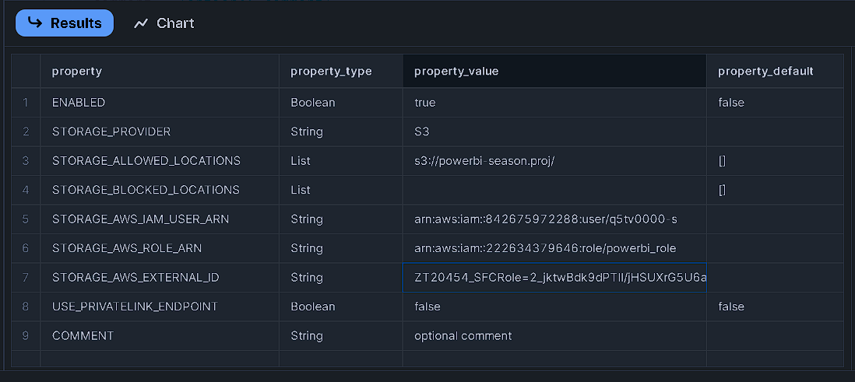**RESULTS:**

***Season-CREATE DB, Schema, Table & Stage***

CREATE database PowerBI;

**RESULTS:**

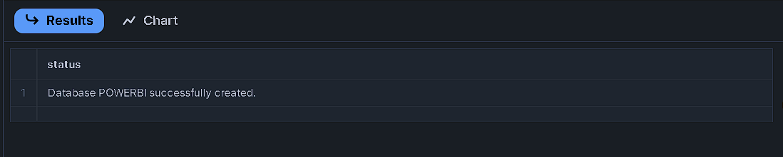

create schema BI_Data;

**RESULTS:**

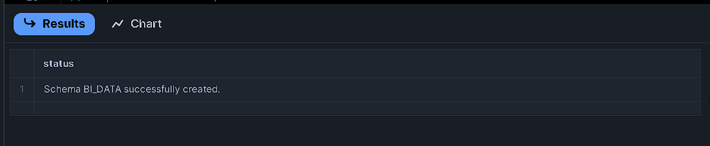

create table BI_Dataset (

Year int, Location string, Area int,

Rainfall float, Temperature float, Soil_type string,

Irrigation string, yeilds int,Humidity float,

Crops string,price int,Season string

);

**RESULTS:**

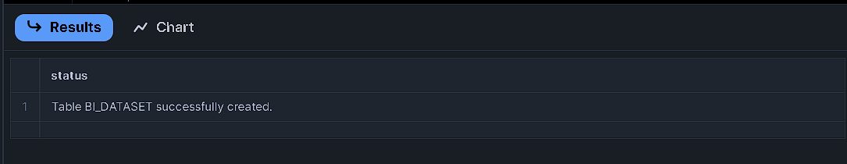

select * from BI_Dataset;

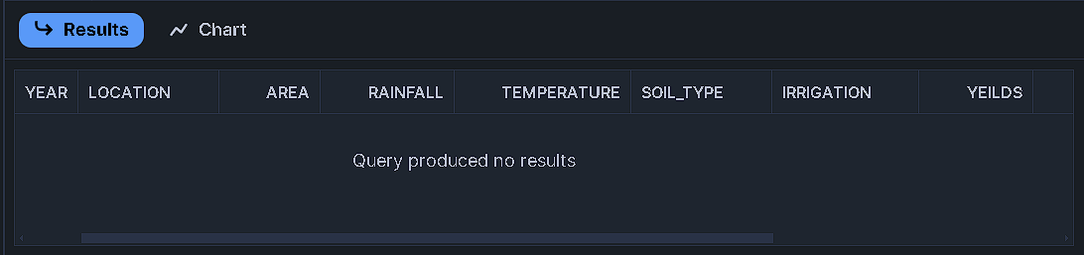**RESULTS:**

create stage BI_Data.s1

url = 's3://powerbi-season.proj'

storage_integration = integration_PBI

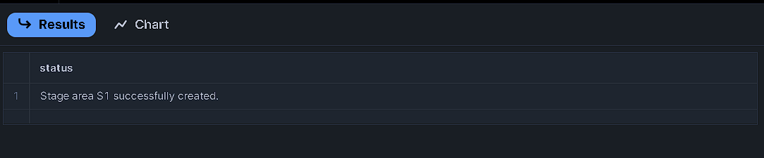**RESULTS:**

copy Into BI_Dataset

from @s1

file_format = (type=csv field_delimiter=',' skip_header=1 )

on_error = 'continue'

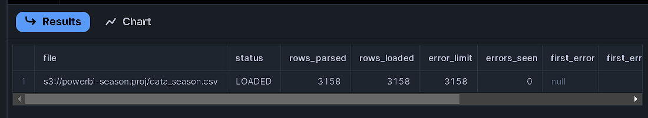**RESULTS:**

select * from BI_Dataset;

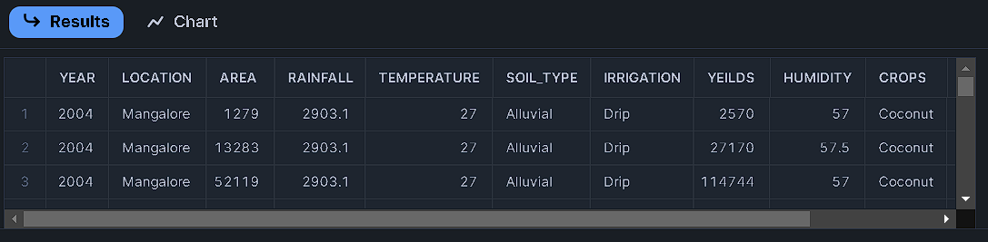**RESULTS:**